Membership Survey Report
Feedback from the Membership
Developed by Judy Nicholson and Michael Shires
March 2015

Contents
Executive Summary .................................................................................................................................... 3
Purpose of the Survey 5
Survey Questions and Responses 5
Findings or Themes 5
Membership 6
Member Participation 7
Member Satisfaction with Work of SLA 8
Priorities for SLA (selected survey responses from Questions 6 &7) 9
1. Advocacy & relations with other organizations, 9
2. Continuing education & conference, 10
3. Networking & social & member engagement, 10
4. Communications (branding, website, newsletter) etc, 11
5. Programming & awards & bursaries, 11
Website Feedback (from Questions 8-11) 12
Purposes for Members Accessing Website 13
Positive Features of Website 13
Features Not Liked 13
Upgrades needed 13
Newsletter Feedback (from Questions 12 & 13) 14
Feedback on Sections of the Newsletter 14
Circulation of Newsletter to Others in Organization 14
Diversity in Library Organizations (from Questions 14-17) 14
Positioned to Serve Newcomers, Diverse Groups, and Aboriginal Peoples 14
Patron Populations 15
Planning to be Relevant to Diverse Populations 15
Ways that SLA Can Support & Assist in Diversity Planning 16

Executive Summary of

2015 Membership Survey Report
This survey, developed by the Membership Committee, Executive, and Executive Director of the Saskatchewan Library Association (SLA), provided member feedback on key priorities of the association. It will also provide input for implementing a diversity plan and for developing a new strategic plan for 2015-2018. There were 120 responses to the survey. Though some questions had as few as 21 responses most were in the 40-60 responses range. In terms of total membership, this is only a partial indicator of members’ impressions of SLA.

Key Observations and Themes
Many respondents don’t know if they hold a membership or what type of membership.
- More information needs to be provided to members on a regular basis.
- The delegates for Institutional memberships need to be contacted to have them provide the number of members covered by their membership and to request that they pass along SLA information.
Many of the respondents have been members for less than 10 years.
- This information highlights the need for new services and programs, and approaches to how SLA does business.
- With many newer members, a continual updating of vision, mission, beliefs, and roles is important.
Traditional activities such as conference attendance, committee work, conference presentations, and board involvement are most common. Newer programs such as program grants and continuing education are less used.
- It is important to communicate this information clearly to members, and to investigate the accessibility and relevance of activities to the members.
- The message needs to welcome all members, library workers, and stakeholders and promote inclusivity.
Members indicated dissatisfaction or a low satisfaction rating with advocacy, support for library workers, and relations with other organization.
- The comments provide the Board with directions for a program review and renewal.

Priority Action Items
Key themes related to Advocacy and Relations with Other Organizations indicate:
- There needs to be more leadership in working with other library related organizations in the province.
- Work at establishing a national voice through federation.
- Activities need to be more focused and to re-vision what direction to work on advocacy which incorporates building relations with the government.
Continuing Education and Conference are essential components for the SLA membership with the conference providing multi-sector appeal.
- Provide education on libraries in Saskatchewan and how they work together.
- Provide information on library related organizations that facilitate collaboration and sharing between sectors (e.g. Multitype Library Board (MLB), Saskatchewan Information and Library Services Consortiium (SILS), Multitype Database Licensing Program (MDLP)
- We need to find out what special library members, school library members, and academic library members need from SLA (there is a perception that the supports are there only for public libraries)
Networking, Social, and Member Engagement has improved with SLA over the past few years.
- These are enhanced by the introduction of the SLAte e-Newsletter, newsflash communications, and more frequent updates to SLA’s website.
- Committee and board involvement has been stronger.
- New (and younger) members might be interested in doing things differently or taking on new approaches.
Communications such as the newsletter and website were applauded.
- Some projects such as information on best practices, what other libraries are doing, and implementing the forthcoming diversity plan are important.
- A rebranding effort would encompass the communication tools.
Programs category was missing from the satisfaction feedback.
- Members indicated that programs could use some refreshing and it needs to be determined how to make them relevant to the broad range of members, and to library communities.
- Many program suggestions were offered to help build a diversity strategy.
A concerted effort this year to develop a diversity plan resulted in many responses from the membership that indicated most libraries have less than 20% of their patron population being newcomers and Aboriginal peoples.
- Only about half the respondents indicated that they had plans in place to be relevant to diverse populations.
- There were several suggestions for activities that would support library work with diverse populations.

Membership Survey Report

Purpose of the Survey

This survey was developed by the Membership Committee, Executive, and Executive Director of the Saskatchewan Library Association (SLA) to provide member feedback on key priorities of the association. SLA is involved in developing a diversity plan in the summer of 2015, as well as preparing to develop a new strategic plan for 2015-2018. The member feedback provided in this survey will provide direction, guidance, and support for ongoing work by the SLA Board of Directors and staff.

Survey Questions and Responses

There were 120 total responses for the survey. It was available for two weeks in February 2015. The response rate was quite low to many of the questions with only a single answer providing a response rather than a trend indicated by several responses. Responses that have multiple responses of similar themes have more relevance. Questions 1, 2, 4, 5, and 7 have a response rate of over 50%. The remaining 12 questions have a response rate less than 50%.

Themes in Survey

Membership
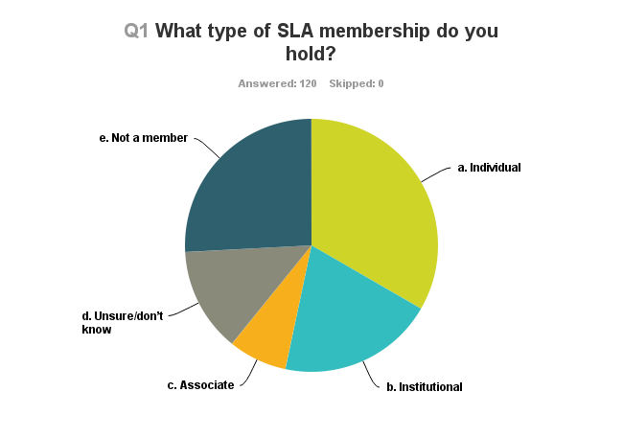
Observation: 48 of the 120 respondents (40%) did not hold memberships or weren’t sure what type of membership they held, if they had one at all.

Recommendations:
- Contact institutional voting delegate and ask them to circulate communication and to promote institutional membership benefits with the employees of their institution.
  - Inquire how many of their employees are covered by the institutional membership.
  - Clarify for single institutional membership that only 2 people are covered.

Length of Membership
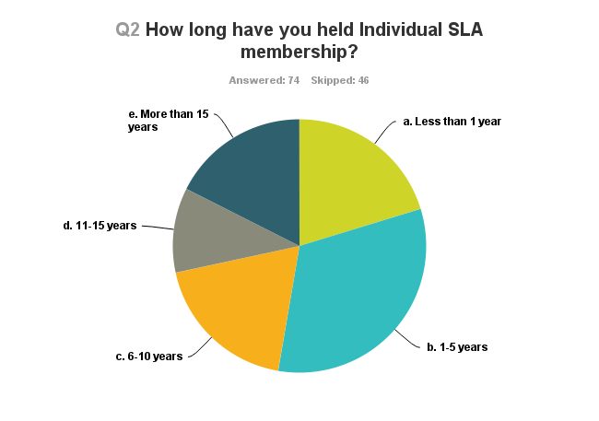
Note: The Question 2 response rate was 62% because it was only answered by those that had selected individual membership in Question 1.

Observations:
- 53% of respondents have held memberships for 5 or fewer years.
- In Question 3, of the 26 respondents who do not currently hold an individual membership, 15 (57.7%) indicated that they never had an interest, 4 (15.4%) previously held individual memberships and are now covered by institutional, and 7 (26.9%) chose not to renew.

Recommendations:
- With more new and potentially younger members there will be a need for new services and programs, and fresh approaches to doing what SLA does. There will be less of an emphasis on the traditional ways of doing business.
- Investigate possible ambivalence among experienced members or those soon retiring. Is there a membership retention issue?
- Presentations to the membership about SLA’s vision and mission will be significant.
- Question 3 reinforces the need to do more member education about benefits of a membership and the distinction between the different types of membership. It is important to make the benefits relevant to what members need.

Member Participation
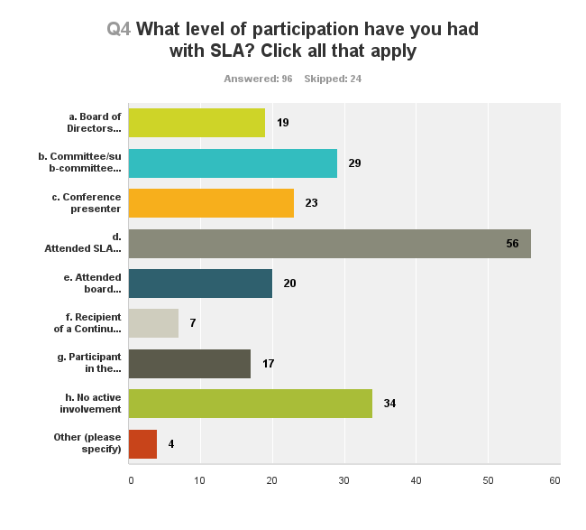

Observations:
- The annual conference is by far the most significant activity in terms of involvement and is also the most accessible to many members on a regular basis.
- Of those who are engaged, the most common activities are: conference attendance, committee work, conference presentation, and board involvement.
- The activity that provides continuing education or program grant money was the least popular.
- 34 of the 96 respondents (33%) are not actively involved in any SLA activities.

Recommendations:
- It is essential to have open communication channels with members.
- Investigate accessibility and relevance of activities
- Create a sense of inclusivity and a welcoming atmosphere so more members are actively involved in SLA.

Member Satisfaction with Work of SLA
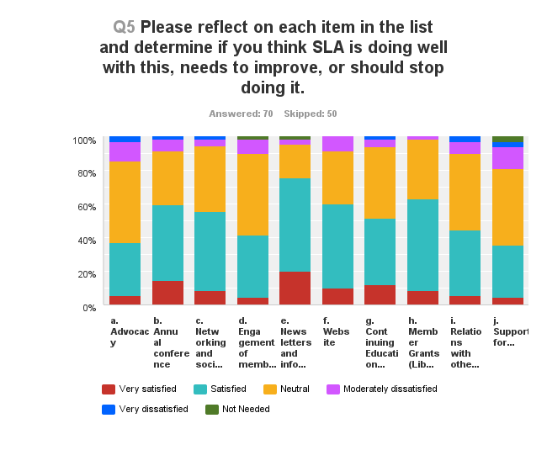Observations:
- On each question at least 20% - 49% of respondents selected “neutral’ indicating a flaw in the survey design. There needed to be a clear division on either the satisfied or dissatisfied side. The question and the choices also didn’t match.
- The scale of satisfied/neutral doesn’t give an indication of whether to stop providing the offering or improve it.
- The not needed category only had 4 responses – one each of engagement of members on boards and committees and for newsletters and informational announcements, and 2 for support for library workers.
- The strongest satisfaction is for Conference, Networking and social events, Newsletters, Website, and Member grants.
- The most dissatisfaction was with Advocacy, Support for library workers, Relations with other organizations.

Recommendations:
- Find ways to discover the reasons for the dissatisfaction while noting that the responses represent a small percentage of the membership.
- Neutral responses can also be interpreted as maintain the status quo.
- If neutral responses are disregarded and only compared with those on each side it provides a comparison of satisfied with dissatisfied. See table below.

- Advocacy 2. Conference 3. Networking & social
4. Member Engagement 5. Newsletters 6. Website
7. Continuing Ed 8. Member grants 9. Relationships other organizations
10. Support for library workers/

Priorities for SLA (selected survey comments from Questions 6 & 7)

Note: One respondent commented that priorities should have been weighted as pillars instead of being ranked.

Note: The recommendations from Q17 have been incorporated into the following responses which are organized by the themes indicated in Questions 5 and 7.

Advocacy & relations with other organizations,
- working with other provincial organizations:
  - It might be an idea to have the president of SLA to lead an annual meeting of the presidents of other library associations like library technician, or library related associations in the province to see where they might be able to collaborate on continuing education, conferences, advocacy, etc.
  - Collaboration or amalgamation with other Saskatchewan library associations (SALT, SLTA, SHLA, SSLA), so we are all bigger and stronger together.
  - More advocacy at the provincial level, better cooperation between the different types of libraries within the province to support libraries, tying such support to community and economic development (i.e., vote-winning priorities for politicians),
- SLA has recently been un-focused in advocacy because it doesn't know what kind of advocacy it wants to pursue or should pursue.
- I can appreciate that it is difficult to get volunteers to do it as many library staff have no experience in this area. I can also appreciate that a small organization with a small, somewhat diverse and very interconnected membership would find it difficult to
determine its position on political issues.
- More relationship building between government and the SLA Office - regular meetings between our ED and the Minister
- Working nationally:
  - We have a long history of collaboration in SK - SLA should be a founding member of a strong national federation of library associations. Advocacy needs to be done through a national organization.
  - At the provincial level SLA does not have credibility.
- Diversity: Advocacy and lobbying legislators ( 2 comment)
- Diversity: Building bridges with other organizations serving similar groups
- Diversity: Toolkit for higher level planning
- Diversity: Regional libraries need more professional staff in order to expand capacity to take up emerging issues (too often additional staff is temporary)

Continuing education & conference,
- Conference:
  - Conference needs to provide sessions for library workers outside public libraries
  - I liked the fact that the conference last year was not in Regina or Saskatoon. It was a fantastic conference in Moose Jaw.
  - I would like to see sessions for library trustees at annual SLA conferences. The Trustees are a part of the library community and their concerns have been largely overlooked.
- Participation in the Education Institute is very valuable
- It would be great to have some organizations take it upon themselves to offer an introduction to libraries in Saskatchewan and how they work together/what roles they play. What does SILS do? What does Provincial do? How does resource sharing work between the different sectors? What is MDLP?
- Diversity: Conference and EI sessions (3 comment)
- Diversity: Connect with speakers and educators
- Diversity: Awareness training

Networking & social & member engagement,
- We need to listen to our younger crowd and be willing to do things differently - add some element of fun so that people will participate
- good work is being done to engage members on the Board and on committees - keep it up and continue to provide opportunities for involvement. Members need to step up.
- My dissatisfaction with Engagement of members on boards and/or committees is not for SLA but for our membership. I hope there will be more involvement by members directly with the association.
- Get started earlier, so they can start their work in June. Find a way to convince people that there is role for them - even if it is very small one. Once people feel part of something, they tend to stay involved.
- SLA appears to be aimed at professional library workers as opposed to the technicians or assistants but that may be just miscommunication on the part of an institution.
- Support for library workers - As a Library Technician in a special library, it is my personal feeling that too many resources are placed in supporting the public library sector and librarians in general.
- A lot of improvement in the presence of SLA in the past few years and it is looking good on the Website.
- Diversity: Building bridges with other organizations serving similar groups

Communications (branding, website, newsletter) etc,
- The email newsletters are great--I feel more connected to SLA than I have at many other points in time
- a lot of improvement in the presence of SLA in the past few years and it is looking good on the website.
- There has been definite improvement here with the NEW newsletter.
- Keeping lines of communication clear and open between the office, the Board and the regular members.
- Use website and newsletter to find out about conference and events, membership renewal
- Diversity: Information on best practices and what others are doing (2 comments)
- Diversity: More communications about what other libraries and SLA are doing (4 comments

Programming & awards & bursaries,
- SLA needs to develop new programming, and not always do the same three big events/activities
- the Mary Donaldson Trust is an unwieldy structure with a dwindling pot of money - we should break it up as a Trust, but still do those activities (lecture, award) through other more flexible committees
- We need to build stronger bridges with families with children 0-6 years and public schools and library branches through welcoming program activities that encourage literacy development.
- There does not seem to be an adequate form of communication between the libraries/librarians. No way for them to communicate with each other. To share ideas for programming, how to increase patrons,
- Grants are great except the amount is always going down (i know that it is not your fault) yet the cost of the programming is going up. Maybe instead of spreading it around, there should be different criteria for it being awarded and an emphasis on supporting Aboriginal communities
- Diversity: Finding resources that are affordable and useful (2 comments)
- Diversity: Celebrate success
- Diversity: Use SLA grants to create relevant programs (2 comments)

Member Satisfaction with SLA Work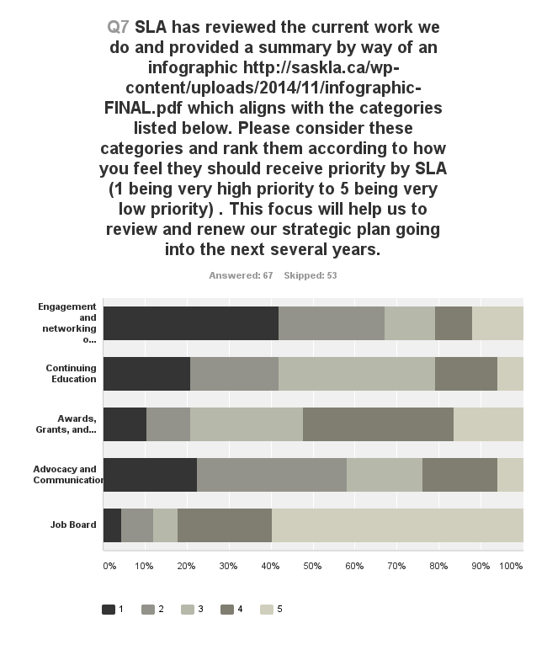

Website Feedback (from Questions 8-11)
In Question 11, the score out of 10 to review the website, 81% of respondents combine for a score of 5-8 with an average of about 70%, about 33% are at 8, 20% 5 and under, 13% at 9 & 10. Unfortunately there are no criteria so there is no description of what it was the scoring represented.
The responses below are taken from Questions 8,9, and 10. Items below are tallied by number of responses.

Purposes for Members Accessing Website
- Conference - 22
- upcoming events - 10
- News - 9
- Continuing Ed - 8
- job boards - 6
- Programs - 5
- Contact information – 4
- Board info -3
- Advocacy , About libraries – 2 each
- Membership renewal , Mary Donaldson Lecture, Finance - 1 each

Positive Reponses- Features of Website
- Easy to navigate - 12
- Clean interface – 6
- Drop down menus - 5
- Attractive - 4
- Homepage look and links to articles, images -3 each
- Up-to-date , Easy to read, User friendly, Pretty nice, Professional looking, Works on smartphone, Improved membership and benefits, Nice layout, well designed and thought out – 1 each

Negative Responses - Features of Website
- Don’t use it - 7
- No comment -8
- Navigation on left hand side – appears and disappears ,Advertising flash on side – distracting – get rid of it (and company spamming -3 each
- Feels cluttered, lots of text on main page needs to simplify - 2
- No clarity between articles and events on mainpage - 2
- Looks tired, needs to upgrade, Light blue writing is hard to read against a white background – 1 each

Upgrades needed
- Move governance to the top –easy to overlook, more colour needed – 3 each
- Curate resources and provide links - 2 (I.e. CALL)
- Regular info about provincial libraries, More dynamic , Update more frequently, Back issues of SLAte (we have this), Online conference registration (we have this), Use member photos instead of stock photos - 1 each

Newsletter Feedback (from Questions 12 & 13)

Feedback on Sections of the Newsletter
Less than 50% of the respondents provided feedback on the sections of the newsletter, and of these, only 4 responses indicated that the sections were not informative. The highest percentage of responses were in the category labelled “informative”. Responses in order of the weighted average from highest: program news, letter from the president, save the dates – events, board news, for your information, links.

Comments:
- Don’t want more information, timely and important information is most valuable
- Re-purpose the newsletter content to Twitter
- More information about what people are doing in libraries around the province – though getting submissions may be difficult
- Sub-sections for different libraries/service types – though difficult – such as annotated bibliographies, program experiences, staffing changes
- Like the look and like getting it electronically
- Provide context for links
- Reports from other committees – not just President
- Advocacy tips for regional boards and local library boards
- Use less text
- People Profile – welcome messages and bios of newly hired librarians in the province

Circulation of Newsletter to Others in Organization
Observation: Respondents indicated 28% Yes and 72% No. When filtered for only Institutional members, the No response was somewhat higher.
Recommendation: Encourage each Institutional delegate to circulate the newsletter to all people in their organization.

Diversity in Library Organizations (from Questions 14-17)

Positioned to Serve Newcomers, Diverse Groups, and Aboriginal Peoples
Yes (19 times) No (2 times) Not sure or no comment (3 times)

Selected Survey Comments
- Diversity openness and awareness, but not for service outside of English language
- Literacy books for learning English but out-dated and new resources difficult to find (provide more information about this in the newsletter)
- The institution has the resources, but we could do a better job of incorporating into library service.
- Libraries are challenged with racism, ignorance, and lack of communication with underserved groups.
- As a small branch with a high Aboriginal patron group, we are asked for and provide service to people with other first languages
- Special libraries provide resources to their patrons on specialized topics, a change of patron groups could extend possibilities for other services. Patrons not necessarily reflective of larger population.
- Aboriginal awareness training for staff, Aboriginal summer student program ,
- Programming committee mandated to focus programming on newcomers, Aboriginal people, people returning to workforce, and seniors – and this is pushing us to new directions.
- Used some of SLA program grants to hold newcomer programs
- Trying to identify needs and how to accommodate them in the municipality.
- Further support/resources from SLA would be helpful
- Working into organization’s strategic planning
- Mandate, defined staff roles, and collection development practice designed to support libraries in Saskatchewan to serve newcomers, diverse groups, and Aboriginal peoples.

Patron Populations
Most libraries have less than 20% of their patrons in the newcomer or Aboriginal population groups. Only one library indicated 60-80% newcomers, while 3 respondents indicated 81-100% of the patrons were Aboriginal peoples.

Planning to be Relevant to Diverse Populations
Of the 41 respondents to this question, 49% said yes and 51% said no. When filtered to show those with a plan in place, the ratio in patron populations was fairly similar to that of the full response.

Selected Survey Comments
- In our institution’s strategic plan, with specific units serving specific groups as their main focus
- Aligning the library plan that will link to the institution’s strategic plan
- Future strategic planning will include these items
- Ensuring staff is aware of needs of diverse populations, that spaces reflect needs of different populations and are welcoming
- mandated programming focus for these groups * targeted collections (aboriginal content collections, multilingual collections, and English Language Learning collections) * services for these groups (tours, student internships. Cree language learning, outreach to community agencies for partnerships, etc.) * employment equity policies, student internships, etc. We hire a lot of newcomers to work for us
- We currently have a satellite branch within a predominantly Aboriginal neighbourhood and we hope to increase the hours of operation and collection there. We have applied also for a federal grant that would provide us with the resources to better support newcomers, jobseekers, and skills training that would benefit Aboriginal peoples and newcomers.
- Actively recruiting members from both of these population groups (ie. dinner meetings, school visits) Currently newcomers and aboriginal groups account for about 25% of population,
- The University's Strategic Plan deals specifically with these issues and the library attempts to implement it in our collections and services by having for instance aboriginal centre reference services and a multilingual collection through Provincial Library.
- Mandated for adults but not kids or teens
- My library will follow some initiatives in the University's new strategic plan titled Peyak Aski Kikawina (Together We are Stronger) http://www.uregina.ca/strategic-plan. My library currently has an agreement with PLLO with sharing its Heritage Language collection. MARC records are available in our ILS and blocks of 100 titles are available for immediate checkout.

Ways that SLA Can Support & Assist in Diversity Planning
Note: These comments were also integrated into the comments section about SLA Priorities (see pages 7 -9 of this report).
- More communications about what other libraries and SLA are doing (4 comments)
- Conference and EI sessions (3 comments)
- Information on best practices and what others are doing (2 comments)
- Finding resources that are affordable and useful (2 comments)
- Use SLA grants to create relevant programs (2 comments)
- Advocacy and lobbying legislators (2 comments)
- Connect with speakers and educators, Toolkit for higher level planning, Toolkit for higher level planning , Awareness training , Celebrate success , Building bridges with other organizations serving similar groups , Regional libraries need more professional staff in order to expand capacity to take up emerging issues (too often additional staff is temporary) (1 comment each)

